Bug Report

Below shows the defects(bugs) found in the application during various phases of testing:

**Project: Buggy Cars Rating**

**Issue type :** Bug

**1. Defect Summary:**

On navigating to Lancia Stratos image on overall rating page displays as blank

**Steps to Reproduce**

As a registered or unregistered user

1. Login to <https://buggy.justtestit.org>

2. Click on Overall Rating section

3. Navigate to the page 4 of 5 navigation button >>Click on Lancia Stratos image

**Actual Result:**

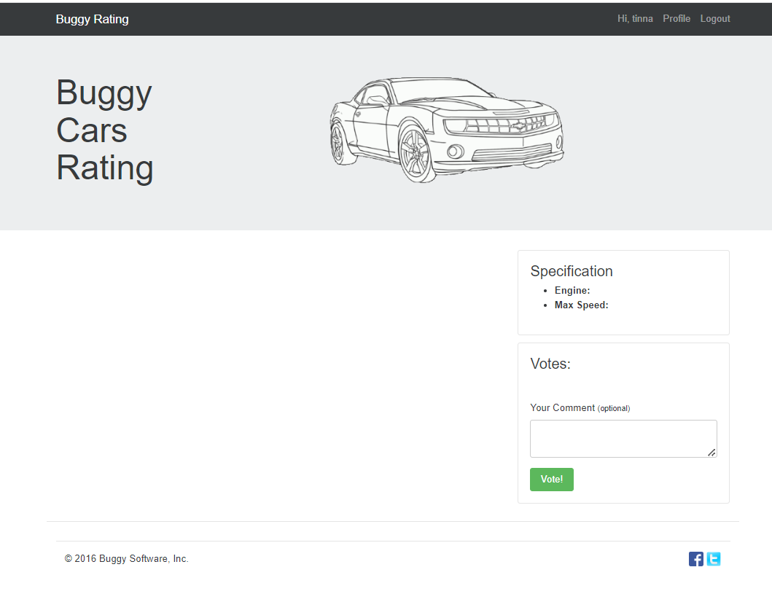

**Expected Result:**

Image and content should be displayed for Lancia Stratos.

**Severity:** Critical

**2. Defect** **Summary:**

Registration page - Password and Confirm Password field does not have any hover-over or text message underneath the field to show the expected criteria e.g minimum number of characters, any special character required

**Steps to Reproduce**

1. Go to https://buggy.justtestit.org

2. Click on Register button on the top of the page

3. Fill in Login, FirstName, Last Name, Password and Confirm Password as "Var234"

**Actual Result:** It displays error message as InvalidPasswordException: Password did not conform with policy: Password not long enough

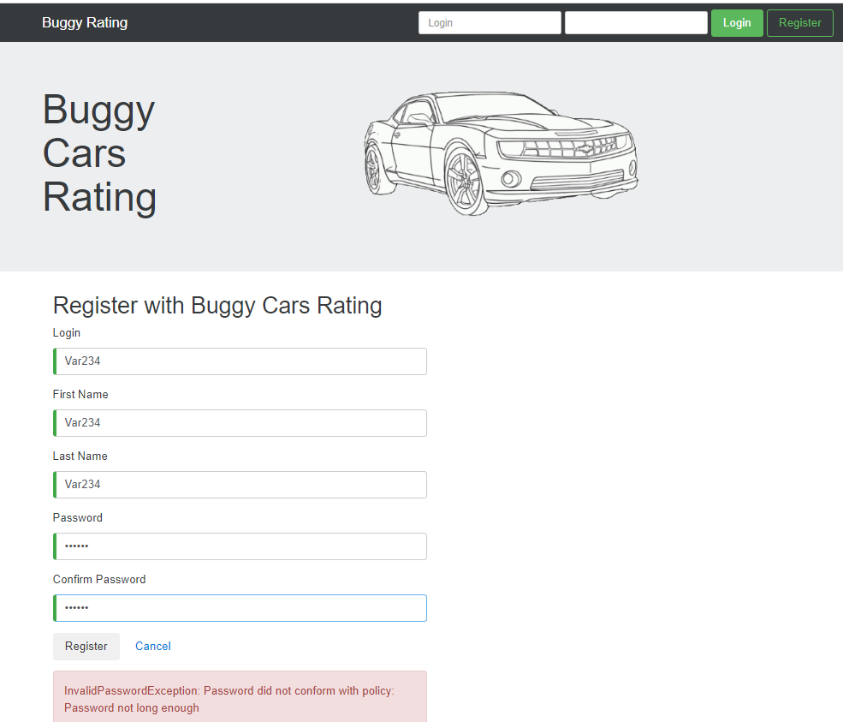

**Expected Result:** Password field should display a hover-over or a text message showing the accepted criteria for the field as per the requirement specification

4. Now delete both the password and try "Var234567" and Click Register

**Actual Result**: It display error message as InvalidPasswordException: Password did not conform with policy: Password must have symbol characters

**Severity**: Minor

**3. Defect** **Summary:**

From Popular Make page, clicking on "Buggy Rating" on the header, does not navigate the user to the homepage – Broken link

**Steps to Reproduce**

1. Login to <https://buggy.justtestit.org> with Valid credentials as a registered user

2. Click on Popular Make Alfa Romeo logo

3. Click on the Buggy Rating on the left corner top of the Alfa Romeo Make page or the Alfa Romeo logo

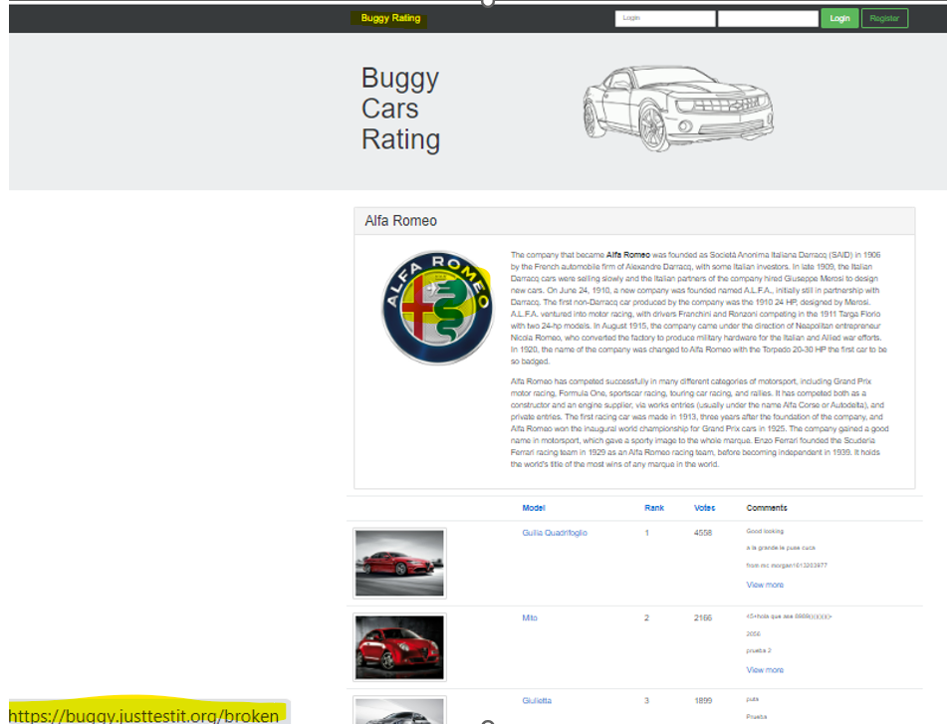

**Actual Result:** Buggy Rating Link is broken and not navigated back to home page

**Expected Result:** To be consistent with other flows, Buggy Rating should be clickable and navigate user to the homepage as it does when user clicks on Buggy Rating from Popular Model or Overall Rating page

**Severity :** Critical

**4. Defect Summary:**

In the Overall Rating page, image of car Lanci - Ypsilon is not displayed and on click of image in the Lancia description page shows broken image next to its logo

**Steps to Reproduce**

1. Login to <https://buggy.justtestit.org>

2. Click on Overall Rating section

3. Navigate to the page 4 of 5 navigation button >>

i) click on broken image

**Actual Result:** Refer highlighted - Image of car Lancia- Ypsilon is not displayed (broken)

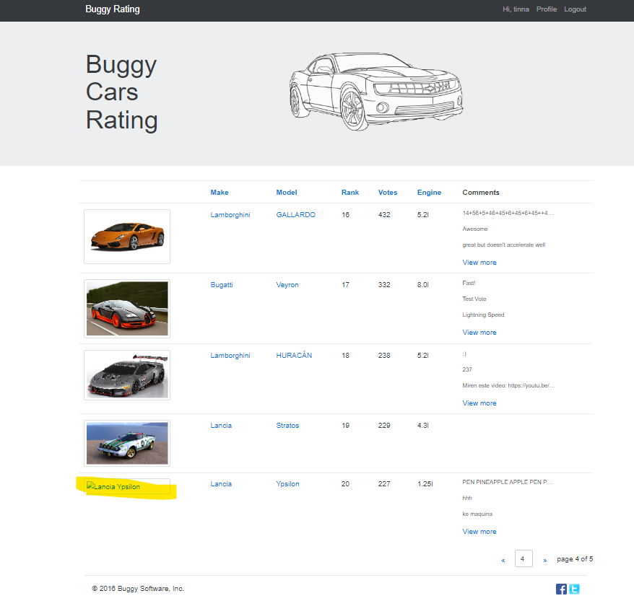

**See below after clicking the broken image**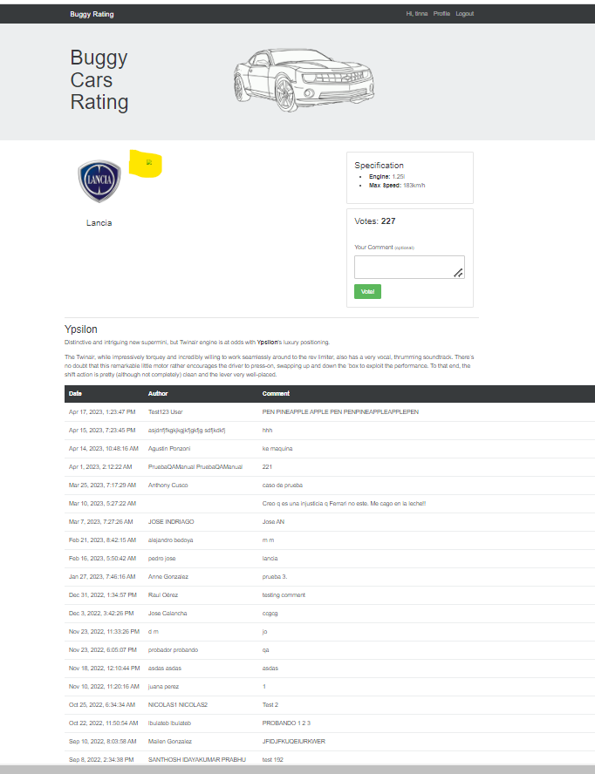

**Expected Result:** Image of car Lanci - Ypsilon should be displayed

**Severity :** Major

**5. Defect Summary:**

Lamborghini description page and clicking on "Buggy Rating" on the header or the logo, does not navigate the user to the homepage – Broken link

**Steps to Reproduce**

1. Login to <https://buggy.justtestit.org> with Valid credentials as a registered user

2. Click on Overall rating page and on first page click on Lamborghini diablo image

3. Click on the Lamborghini logo -> Lamborghini description page displayed

4. Click on Lamborghini logo or Buggy Rating on the left corner

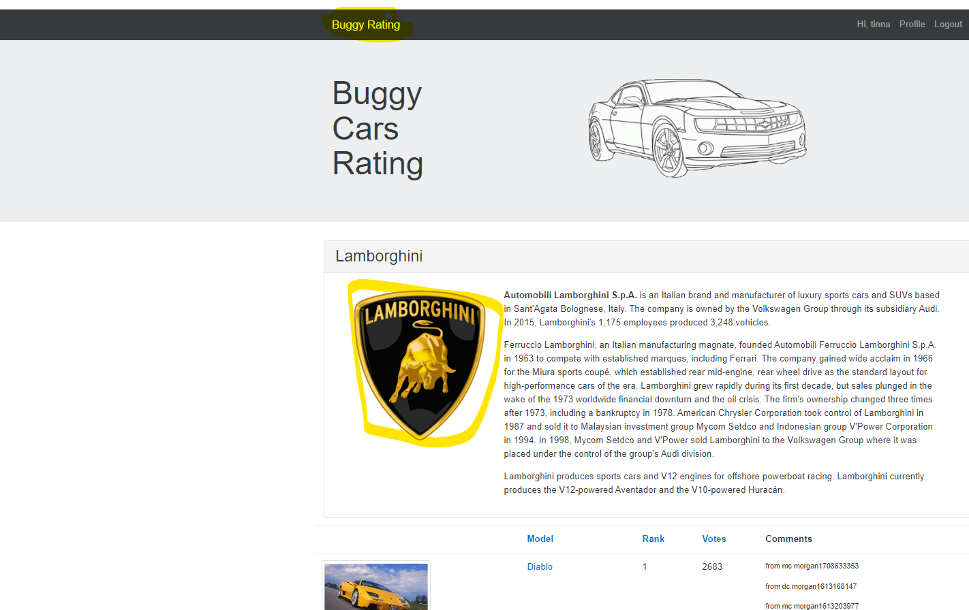

**Actual Result:**

On click Image logo and buggy rating text on top left does not navigate to the homepage due to broken link

**Expected Result:**

Image logo and buggy rating text navigated to homepage

**Other defects**

* Same broken link similar to above in Pagani page not navigating to homepage on buggy rating and pagani image logo **– Major**
* Author section blank

